Basically, in this project we are going to deploy a PHP application running on a EC2 instance, we will need a database instance with the same PHP application can query. The database will be a MySQL, we will update application parameters in a AWS Systems Manager Parameter Store, finally we will secure the application to prevent public access to backend systems.
The diagram of the application will look like this one:
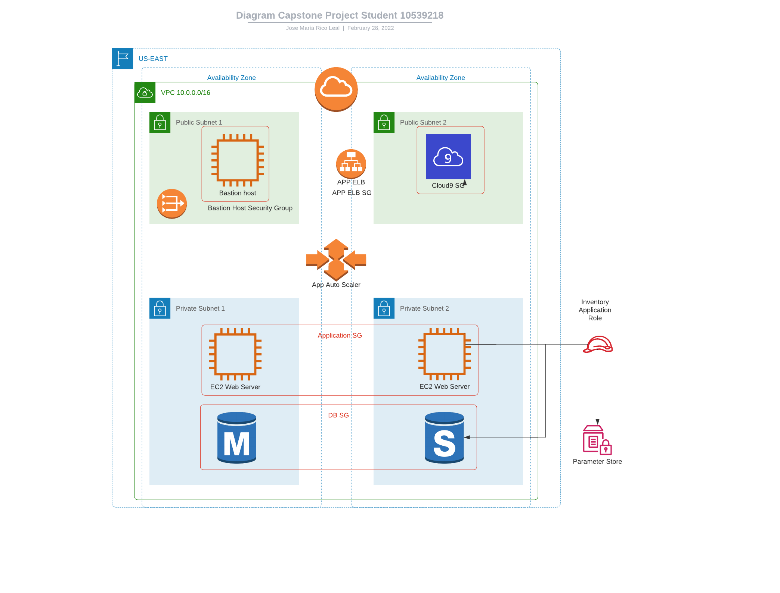
We are going to create a cloud9 IDE accessible and with all project assets. Cloud9 will be used to deploy the PHP application and will be used as well to import data to the database (Private subnet 2). After this, an application load balancer an auto scaler will be created to launch the private EC2 instance (Public subnet 1), this is how basically the capstone project should work.

